Student name: Terence Tang

Student Id: 40091374

Assignment: Reflection 1

**WHO IS THE ARTIST, WHAT HAVE THE ARTIST CREATED AND WHY I CHOOSE THE ARTIST**

The artist I have chosen to focus on is Yoshi Sodeoka. He is a Japanese-born multimedia artist who has created multiple installations that I find extremely interesting and inspiring. (I also personally find his work very aesthetically pleasing.) Many of his pieces have been exhibited in various museums around the world.

I will not spend too much time discussing his biography, as I do not consider it a crucial factor when observing an artwork. What truly matters is what he has created and the meaning behind his work.

One common characteristic of his art is the use of space. Instead of focusing solely on the artwork itself, he considers space as a important variable in his creations. His work engages in a conversation with the environment in which it is exhibited. The designs are crafted to best complement the space. For example, he has created installations that are projected onto architectural structures. His designs are made in a way that highlights the unique characteristics of these buildings.

Another reason I have chosen to write about his work is the inspiration it has given me. I have always been interested in space as a subject. How can I transform an existing space into part of my creation? By stepping into this space, the viewer becomes immersed in an environment I have designed. It is not simply about projection mapping; rather, it is about the combination of technology, creativity, and space.

Observing his work leads me to ask myself: How is this made? What tools did he use? Am I capable of creating something similar? I am not talking about imitating his work but rather analyzing it from a technical perspective. By doing so, I discover new tools and learn how to use them. I believe this is an essential step for me to take in order to achieve my artistic goals

**ONE OF HIS ARTWORK**

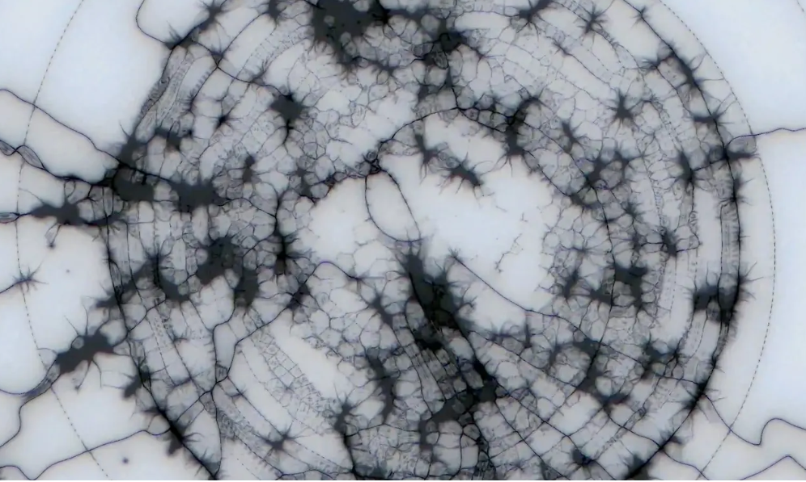Among the various works Yoshi Sodeoka has created, I find *The Flood - Multiplied* particularly interesting. It is a collaborative piece with artist Chia Amisola and is one of the artworks exhibited in *Root Access* at MoMA. The artwork uses an application called MoMAR v5 to transport viewers into an environment crafted by the artists. Through this work, the museum space is transformed into a world created by Sodeoka and Amisola. (***The Flood***)

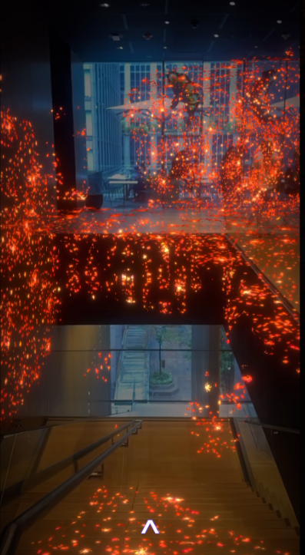Here, I will primarily focus on the part created by Sodeoka. His work features an animation of spiders wriggling across the walls and ceilings of MoMA. This piece is based on his earlier work, *The Flood*, which is an algorithmic animation. We can see how *The Flood*, originally a digital animation, inspired him to develop *The Flood - Multiplied*, an immersive installation. By incorporating AR technology, the installation creates a deeply engaging experience.

Unlike traditional interactive installations, which are often set in a single space using sensors and projection mapping, *The Flood - Multiplied* is not restricted to one particular room. Instead, Sodeoka transforms the entire museum into his exhibition space. His work interacts dynamically with different areas, making the whole environment part of the experience.

I find this artwork particularly inspiring because it breaks away from conventional approaches to interactive installations. Most interactive works rely on a combination of sensors and projection mapping, which typically force them to set at a fixed location. By utilizing AR technology, Sodeoka removes this limitation, expanding the installation beyond a single showroom and turning the entire museum into his stage. (***The Flood - Multiplied***)

Here, it is not just the aesthetics that matter—the way the artwork is presented makes it stand out among other installations. Looking at this piece, I have learned an important lesson: as a new media artist, aesthetics alone are not enough. It is also crucial to explore and utilize new technologies to break boundaries and transform the impossible into reality.